

The Platinum Collection

PLATINUM CABernet Franc 2024

Single Vineyard, Bridage Pa, Hawkes Bay

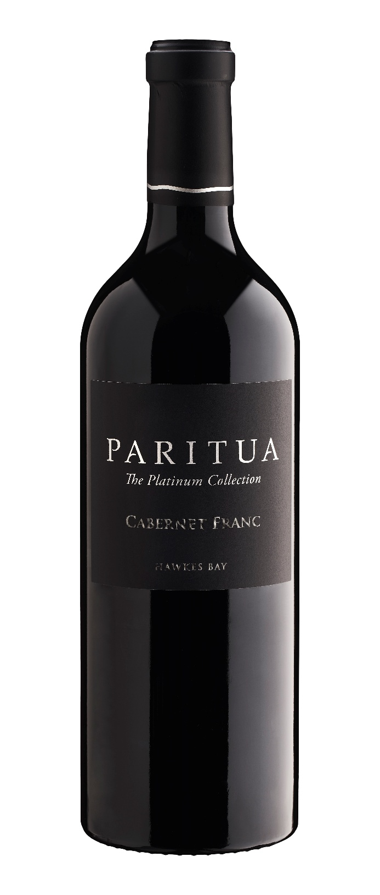
A rich brooding aroma of blackcurrant and blackberry, fragrant violets with dried herbs, dark chocolate and baking spice with oyster shell underlining the complex bouquet. This is a finely balanced wine with a velvet texture, dark plum, blackberry,
a seamless concentrated palate with fine grained tannins, with a hint of
cocoa powder cedar and vanilla oak giving this Cabernet Franc great
structure and length.
____________________ __________________________

Best drinking \

Recommended drinking from 2026 till 2040+.

____________________ __________________________

Blend \
Cabernet Franc 100%

____________________ __________________________

Alcohol \
Alcohol 14% alc

____________________ __________________________

Food Match \
Wild pork game
Red meats
Game fowl dishes
River fish

____________________ __________________________
Viticulture \

Our Cabernet Franc vines are grown at our Paritua Vineyard on Maraekakaho Road.
The vines are managed to crop light and have good fruit exposure. Fruit thinning takes place to one bunch per cane to maximize
ripening potential.
Harvest is all by hand once the grapes have
achieved physiological ripeness.
____________________ __________________________
Winemaking \

Whole bunches are destemmed and partially crushed. After a short cold soak the ferment is started and kept under 30°C.
Regular pump-overs will keep the cap submerged and extract
the fine skin tannins present in this wine.

Malo-lactic fermentation takes place in tank and the wine is put to barrel post maceration.
The wine is racked once before bottling in June of the year following harvest.
We use French oak barriques of which 50% are new.

