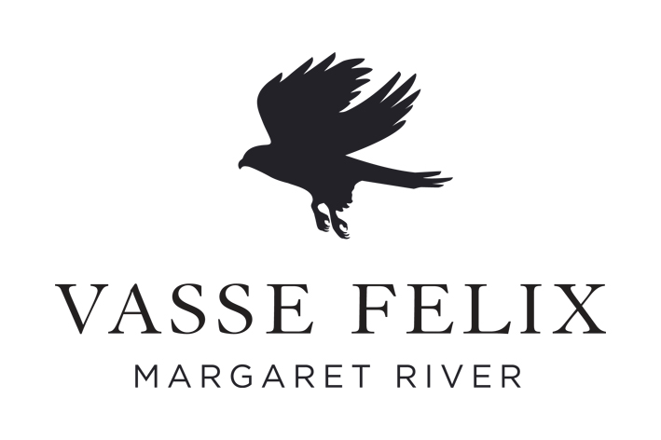

TASTING NOTE TEMPLATE
Wine | 2014 TOM CULLITY
Region | Margaret River, 100% Wilyabrup Home Vineyard
Varieties | Cabernet Sauvignon 80%, Malbec 16%, 4% Petit Verdot
Vintage | 2014
Harvested
Pressing white
Fermentation | 100% wild ferment
Fermentation Vessel | Open and Static fermented
Juice Turbidity (required?)
Yeast | Wild
Pressing red | 100% whole berry
Time on skins | 12-34 days
Maturation vessel | French oak barrique
Oak Age | 62% New
Maturation time | 19 months
pH | 3.44
TA | 6.4g/L
Residual Sugar
Alcohol | 14.5%
Fining | None
Vegan friendly | Yes
Cellaring potential | Now until……
Introduction  (Brief wine style summary. May remain the same from one vintage to the next) | Vasse Felix, Margaret River's founding wine estate, was established by Dr Thomas Brendan Cullity in 1967. Among his first plantings were Cabernet Sauvignon and Malbec vines, from which he produced the estate’s first red wine. The Tom Cullity descends from these original vines and represents the pinnacle of Vasse Felix.
Tasting Notes

(Will be separated into Appearance / Nose / Palate)
Winemaker Comments

(Winemaking process and additional comments)
Vintage Description  (Brief summary of the vintage and its effect on the wine. Key points only) | Another text-book vintage in Margaret River with consistent, almost rhythmic temperature patterns throughout the ripening season, resulting in excellent balance and physiological ripeness of fruit. Reasonable yields were obtained despite a handful of blocks being exposed to heavy storms in spring reducing their cropping potential, but overall quality is excellent.

